**LEAFY: A Plant Disease Management System**

A project report submitted in partial fulfillment of the requirements for the degree

Of

BACHELOR OF SCIENCE IN INFORMATION TECHNOLOGY

Of

JORHAT INSTITUTE OF SCIENCE AND TECHNOLOGY

UNDER DIBRUGARH UNIVERSITY

2020



Submitted by

**NIHAR KASHYAP (Roll No. 32)**

**PRACHURJYA GOGOI (Roll No. 38)**

UNDER THE GUIDANCE OF :

**Dr. Raju Prasad Paswan** **Mr. Hsuvas Borkakoty**

Associate Professor & HOD Assistant Professor

Dept. Of Agricultural Statistics Dept. Of CS & IT

AAU, Jorhat JIST, Jorhat

**DEPARTMENT OF COMPUTER SCIENCE & IT**

**JORHAT INSTITUTE OF SCIENCE AND TECHNOLOGY**

**JORHAT 785010**

**ASSAM**

**CERTIFICATE**

This is to certify that the project entitled **“Leafy: A Plant Disease Management System”** of JIST submitted to Jorhat Institute of Science and Technology in partial fulfillment for the completion of the major project B.Sc in Information Technology Degree under Dibrugarh University. It is an original work carried out by Nihar kashyap and Prachurjya Gogoi Bsc IT 6th Semester under the guidance of Mr. Hsuvas Borkakoty of CS & IT Department, JIST.

_________________

Signature of HOD

(Mr. Jameson Mushahary) CS & IT Department, JIST

**CERTIFICATE**

This is to certify that the project entitled **“Leafy: A Plant Disease Management System”** of JIST submitted to Jorhat Institute of Science and Technology is partial fulfillment for the completion of the major project B.Sc in Information Technology Degree under Dibrugarh University. It is an original work carried out by Nihar kashyap and Prachurjya Gogoi of Bsc IT 6th Semester under the guidance of Mr. Hsuvas Borkakoty of CS & IT Department, JIST.

_____________________

Signature of Internal Guide

(Mr. Hsuvas Borkotoky)

CS & IT Department, JIST

**CERTIFICATE**

This is to certify that Nihar Kashyap(Roll No 32) and Prachurjya Gogoi(Roll No 38) student of 6th semester, Department of Computer Science and Information Technology, Jorhat Institute of Science and Technology has carried out his Project work entitled **“Leafy: A Plant Disease Management System”** under the guidance of Mr. Hsuvas Borkakoty, Assistant Professor, Department of Computer Science and Information Technology, Jorhat Institute of Science and Technology, for the partial fulfillment of the requirement for the award of degree of Bachelor of Science in Information Technology.

__________________ __________________

Internal Examiner External Examiner

Date: Date:

Place: Place:

**DECLARATION**

This is to Certify that, we student of B.Sc.IT 6th Semester, Jorhat Institute of Science and Technology under Dibrugarh University, have carried out our major project work entitled: -“**Leafy: A Plant Disease Management System**” for Assam Agricultural University in accordance with B.Sc. IT, 6th semester course curriculum and our work is not submitted to any other University/Institute for award of any degree or diploma.

________________ ________________

Nihar Kashyap Prachurjya Gogoi

Roll no.: 32 Roll no.: 38

**ACKNOWLEDGEMENT**

The presented project work is a humble and maiden effort of the work concerned with **“Leafy: A Plant Disease Management System”** and has been a large success for the generous help and guidance received by us from several persons and quarters.

We are greatly indebted to Mr. Hsuvas Borkakoty, Department of Computer Science and Information Technology for ample guidance and encouragement which was an unfailing source of rewards experience.

We would also like to convey our sincere thanks to all who helped and encouraged us during the course of the project. Finally, we thank our parents for providing us with the means to complete this project and above all God for his blessings.

Thanking You

Nihar Kashyap (Roll No. 32)

Prachurjya Gogoi (Roll No. 38)

B.Sc. IT 6th Semester

Jorhat Institute of Science and Technology

**TABLE OF CONTENTS**

**TITLE**  **PAGE NO.**

* Introduction………………………………………………….………………………1
* Problem Statement and Objective of Project………………………………………..2
* Feasibility Study………………………………………………………………….….3
* Software Requirement Specification……………………………………………...…5
* System Design…………………………………………………………………..……8
* A Note on Machine Learning…………………….………………………………....14
* Transfer Learning…………………………………………………………………...19
* Implementation of Neural Network………………………………………….……..20
* Methodology of Detection System………………………………………………….21
* Implementation of Forum…………………………………………………………..23
* Results of Detection………………………………………………………………...24
* Testing……………………………………………………………………………....25
* Snapshots……………………………………………………………………………26
* Conclusion………………………………………………………………………..…30
* Bibliography…………………………………………………….…………………. 31
* Web References……………………………………………………………………..32

**INTRODUCTION**

Agriculture is more than a feeding source for India; it is also the main source of economy for a huge section of people. Profit in the agricultural sector depends on high productivity. However pests and diseases pose a major threat to crops. Early treatment of these diseases is very important to save the crops from extensive damage. This is where early detection systems come into play. It is physically impossible for farmers to inspect each and every corner of the field. To overcome this problem we developed an image based disease detection system. This project titled ‘Leafy’ is Machine Learning based plant disease management system. It uses deep learning to predict the disease of a plant from the picture of an infected leaf. Leafy can predict the disease with 95 % accuracy and show the symptoms and remedies associated with the disease through a graphical user interface. If the user seeks further help he/she can post a question in the Forum section of the website. Our team of moderators and other expert users are dedicated to answer any questions posted on the forum as soon as possible.

**General Terminologies Related With the Project**

CNN (Convolutional Neural Netwok) - It is a way of extracting features from images and make the computer understand them. A convolutional neural network is constructed of multiple convolutional layers. After each layer, we end up with a feature map that will be passed to the next layer. The first convolutional layer will only extract simple features such as edges in different orientations. When we go deeper in the network, the features will become clear parts of the object.

VGG16 (Visual Geometry Group 16) - VGG16 is a convolutional neural network model proposed by K. Simonyan and A. Zisserman from the University of Oxford in the paper “Very Deep Convolutional Networks for Large-Scale Image Recognition”. The model achieves 92.7% top-5 test accuracy in ImageNet, which is a dataset of over 14 million images belonging to 1000 classes. This model won the 1stand 2nd place in 2014 ILSVRC challenge.

Dataset - Collection of excel sheets, images, audio or video used to train the neural network. The quality of data present in the dataset is very important for the neural network to train properly.

Keras - It is an open-source neural-network library written in Python. Keras is capable of running on top of [TensorFlow](https://en.wikipedia.org/wiki/TensorFlow" \o "TensorFlow), [Microsoft CognitiveToolkit](https://en.wikipedia.org/wiki/Microsoft_Cognitive_Toolkit), [R](https://en.wikipedia.org/wiki/R_(programming_language)), [Theano](https://en.wikipedia.org/wiki/Theano_(software)" \o "Theano (software)),or [PlaidML](https://en.wikipedia.org/wiki/PlaidML" \o "PlaidML). Designed to enable fast experimentation with deep neural networks, it focuses on being user-friendly, modular, and extensible.

**PROBLEM STATEMENT AND OBJECTIVE OF PROJECT**

**Problem Statement-**

“To design a disease management that will predict the disease from a given image and show the name of the disease along with symptoms and remedies to the user through a graphical user interface”

**Objective-**

The project tries to fulfill the following objectives –

* To create a Machine Learning Model to detect diseases in the leaves of Potato, Tomato, Corn, Pumpkin and Cherry.
* Promote early detection of devastating crop diseases for the benefit of farmers.
* To provide suitable Remedy and Symptoms for the detected disease.
* Provide a graphical Interface for the user to upload image of the diseased leaf and retrieve the result.
* Provide a Forum Section for Users to ask their doubts and seek help relevant to the scope of the project.

**FEASIBILITY STUDY**

Feasibility is the study of impact which happens in the organization by the development of the system. The impact can be either positive or negative. When the positive nominate the negative then the system is considered feasible. Here the feasibility study can be performed in three ways such Technical Feasibility, Economical feasibility, Operational Feasibility and behavioural feasibility.

**Economic Feasibility:**

Economic analysis is most frequently used for evaluation of the effectiveness of the system. More commonly known as cost/benefit analysis the procedure is to determine the benefit and saving that are expected from a system and compare them with cost, decisions is made to design and implement the system.

This part of feasibility study gives the top management the economic justification for the new system. This is an important input to the management because very often the top management does not get compounded by the various technicalities that bound be associated with a project of this time. A simple economic analysis that gives the actual comparison of cost and benefits is or much more meaningful in such cases.

The project we developed is economically feasible on the user’s part as it does not require anything more than a Smart-phone or Computer and a stable internet connection to operate. On top of that the project was optimized to consume less data and load frequently required data from the cache memory. As such the bandwidth requirement of the project was also reduced. The admin part follows the same principle of low bandwidth and data requirement.

**Technical Feasibility:**

Technical feasibility centers on the technical existing manual system of the test management process and to what extent it can support the system. According to feasibility analysis procedure the technical feasibility of the system is analyzed and the technical requirements such as software facilities, procedure, inputs are identified. It is also one of the important phases of the system development activities.

The system was designed with the latest and best technologies available on the market. It is fast, user friendly and easy to maintain. This project uses Python and SQL to function which are common platforms to work with now days. Technical staff should have no problem modifying and maintaining the project as and when required. With the bloom in web based services in the recent years this system is not only technically feasible but cost effective as well.

**Behavioral Feasibility:**

This includes the following questions:

* Is there sufficient support for the user?
* Will the proposed system cause harm?

It is found that the most of the citizens of this country are well versed with web services and computers. Along with that the project provides tool-tip at necessary places to help the user find his/her way around.

The project would be beneficial because it satisfies the objectives when developed and installed. All behavioural aspects are considered carefully and concluded that the system is feasible.

**SOFTWARE REQUIREMENT SPECIFICATION**

A software requirements specification (SRS) is a document that describes what the software will do and how it will be expected to perform. It also describes the functionality the product needs to fulfill all stakeholders (business, users) needs. For smaller problems or problems that can easily be comprehended; the specification activity might come after the entire analysis is complete. However, it is more likely that problem analysis and specifications are done concurrently. The transition from analysis should also not be expected to be straight forward, even if some formal modeling is used during analysis. Essentially what passes from requirement analysis activity to the specification activity is the knowledge acquired about the system. The modeling is essentially a tool to help obtain a thorough and complete knowledge about the system.

**Analysis of Factual Data:**

Analysis of data is a process of inspecting, cleaning, transforming, and modeling data with the goal of highlighting useful information, suggesting conclusion, and supporting decision making. Data analysis has multiple facets and approaches, encompassing diverse techniques under a variety of names, in different business, science and social science domains. Data mining is a particular data analysis technique that focuses on modeling and knowledge discovery foe predictive rather than purely descriptive purposes.

**Identification of Essential Requirements:**

Identification of the essential requirement is an important task in developing of the project. In this system the essential requirements are identified through surveying. By surveying, the important needs of the user in our web application are known. In the surveying, the different possibilities of tour information that have to be included in the system is given by questionnaire.

Questions included like:

* Need to change to the UI for better usability.
* Is it advantageous over manual methods?
* Need of better accuracy in detection.
* Need for image uploading system

**Definition of Processing Requirements:-**

The user interface for this system will have to be simple and clear. Most importantly, the pages must be easy to read, easy to understand, accessible. The color scheme should be appropriate.

There are many function the system can perform and this must be logically grouped or displayed in a intuitive order to allow the user to perform task quickly and efficiently, without getting lost in excessive amounts of text.

The system must also display large amount of information and to avoid confusion this must be displayed in categories or in different pages. Furthermore, a small amount of information may be displayed initially, for e.g. the title of a question, and the ability to view more in depth information on the question should be apparent.

The system will provide different views for different users, allowing multiple access levels. For example, a standard user will only be able to see their own details and details of their own applications, whereas the administrator will be able to view all users, applications and statistics and will have many more privileges. Being an online system, it will naturally be viewable from any computer or Smart-phone with internet connection. This will provide far more accessibility than if it were written only for one specific platform such as Windows or Android.

**Objective of SRS:**

The objective of this SRS document is to specify software requirements of the Online Application for the designers. It is intended to be a complete specification of what functionality the website provides. The main purpose of the system is to build a disease management system which can detect and provide solution to diseases in a fast and easy manner. Additionally it provides a platform for both agricultural experts and non-experts to mutually solve each other’s problems.

**Overview of SRS:**

The SRS document will include two sections.

1. **Overall Description** will describe major components of the system, interconnection and external interfaces.
2. **Specific Requirements** will describe the functions of actors, their role in the system and constraints.

**Overall Description:**

The SRS document will give further details on the overall product description, including the hardware, software, and communication interfaces, product functions, user characteristics, and any assumptions that will be made.

**Specific Requirements:**

The SRS document will also include the specific requirements needed. This will include the function, performance, design, and software requirements. This document is organized in a logical manner and is easy to follow. Reader’s should refer to the table of content, appendices, or index if looking for something in specific. Otherwise, reading this document from start to finish will start with a vague description and get more specific in detail as changing section and reading further.

**Software requirements:**

|  |  |
| --- | --- |
| OS-Platform | Windows 7,8,10, Linux, Android |
| Front-end | HTML, CSS, JavaScript |
| Back-end | Python Django |
| IDE | Visual Studio Code |
| Programming Language | Python |
| Additional Package | Tensorflow, RemoveBG, Keras |

**Hardware requirements:**

|  |  |
| --- | --- |
| RAM | 4 GB DDR4 |
| CPU | Intel Core i5 – 7300HQ @ 2.50 GHz |
| GPU | Nvidia GeForce GTX 1050 |
| Storage | 2 GB available hard disk space |

**SYSTEM DESIGN**

**Entity Relationship Diagram**

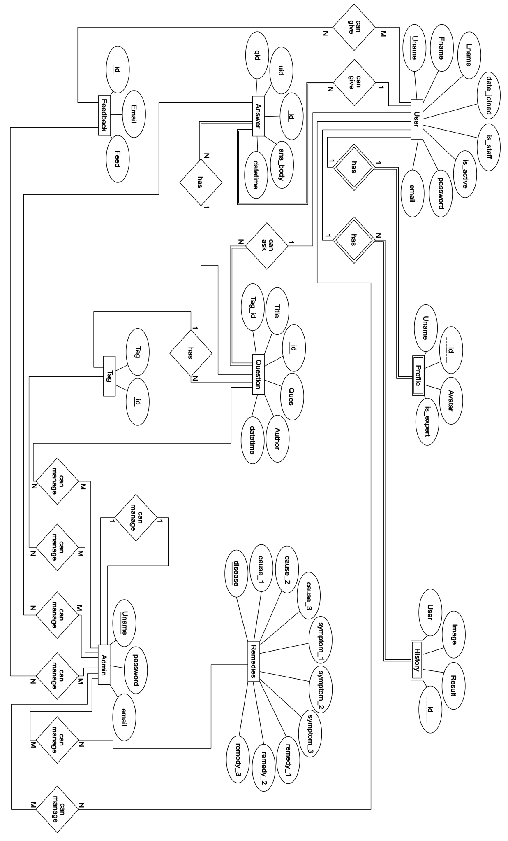

**Dataflow Diagram**

**DFD Level 0**

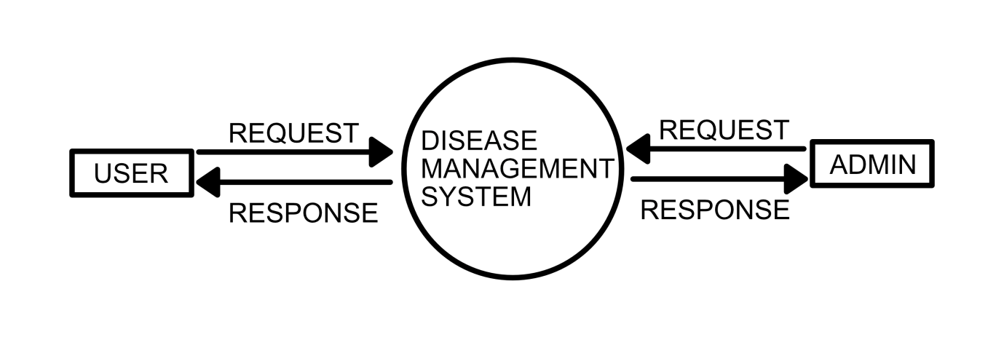

**DFD Level 1**

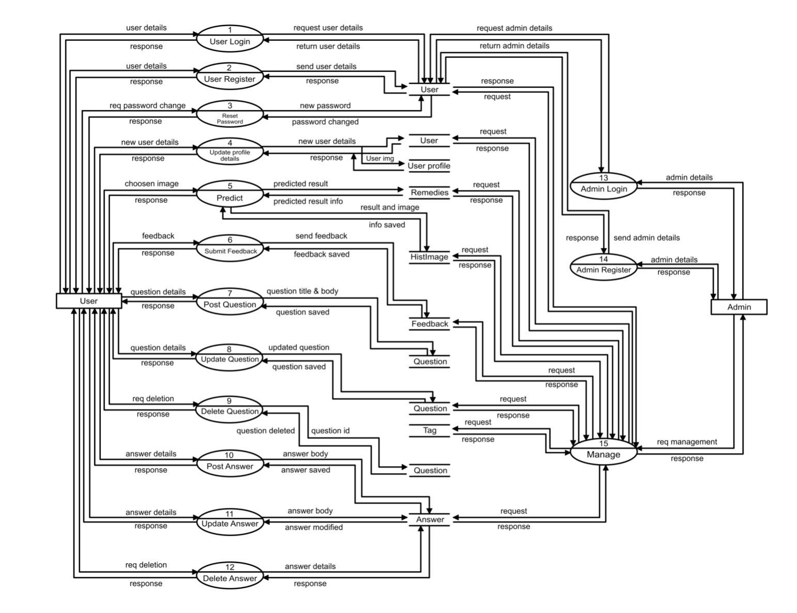

**DFD Level 2**

**Level 2 DFD for User**

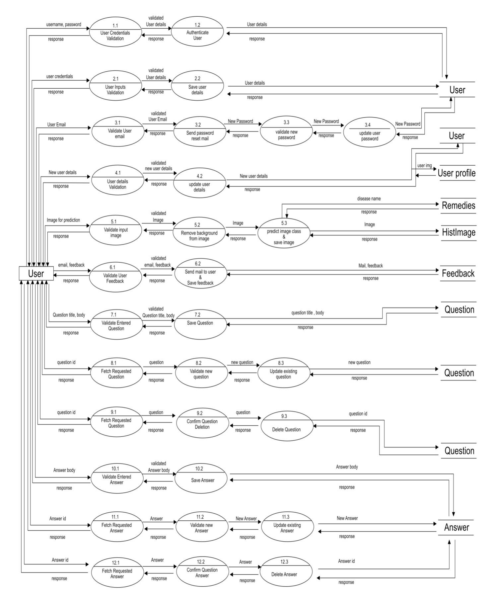

**Level 2 DFD for Admin**

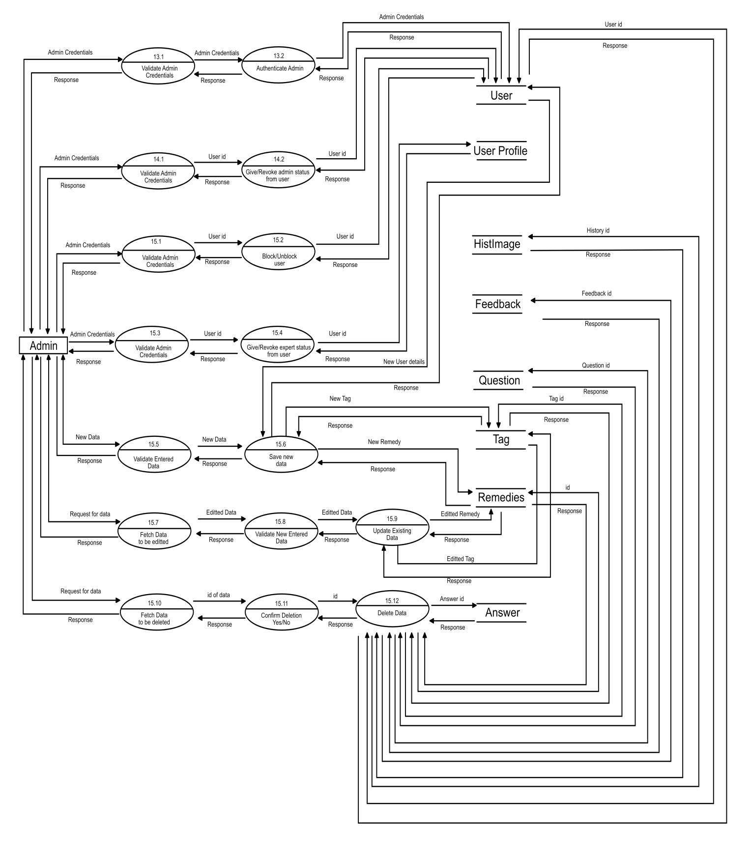

**Relational Model**

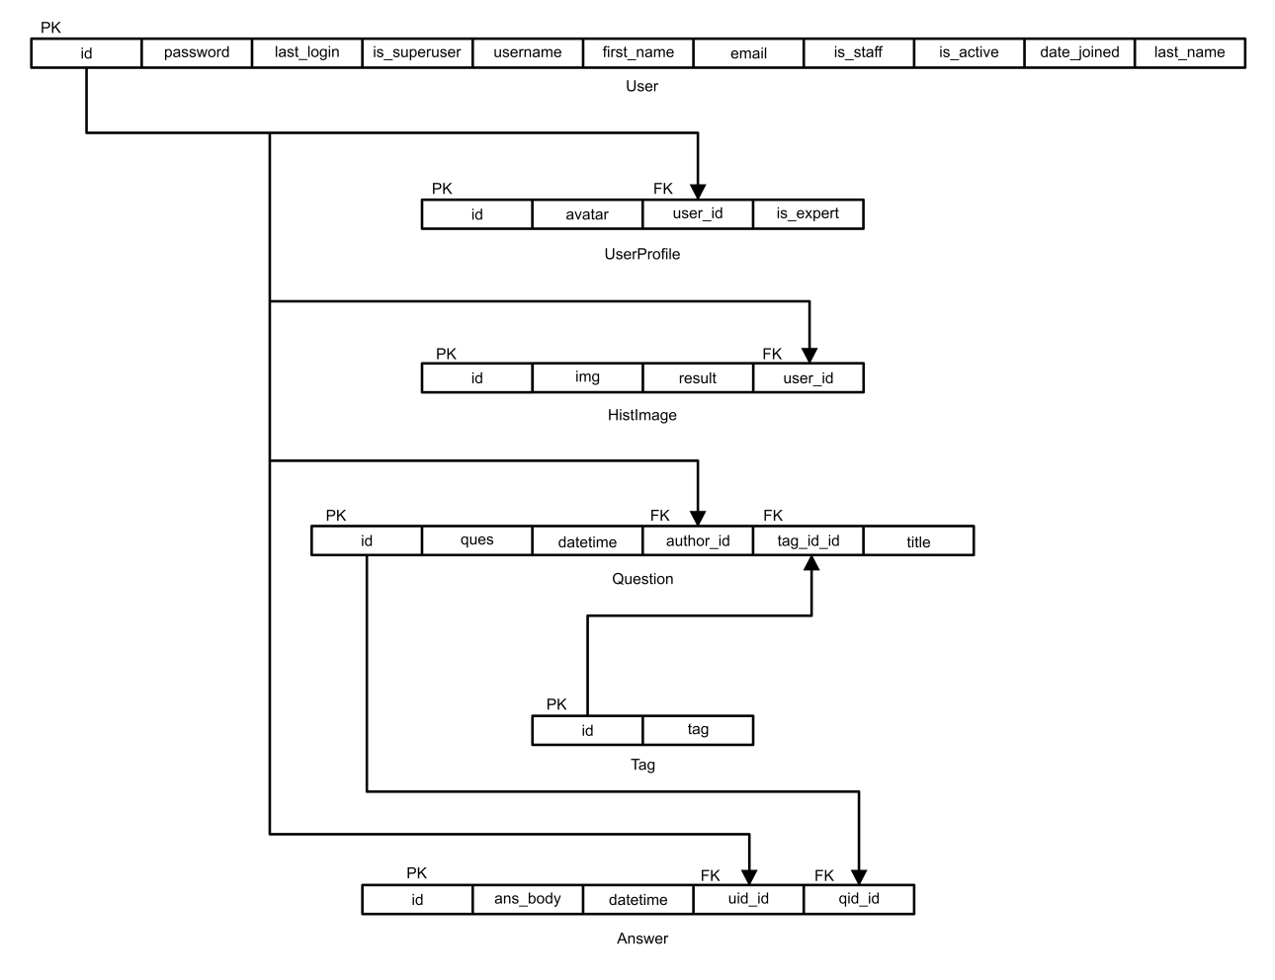

**Network Architecture**

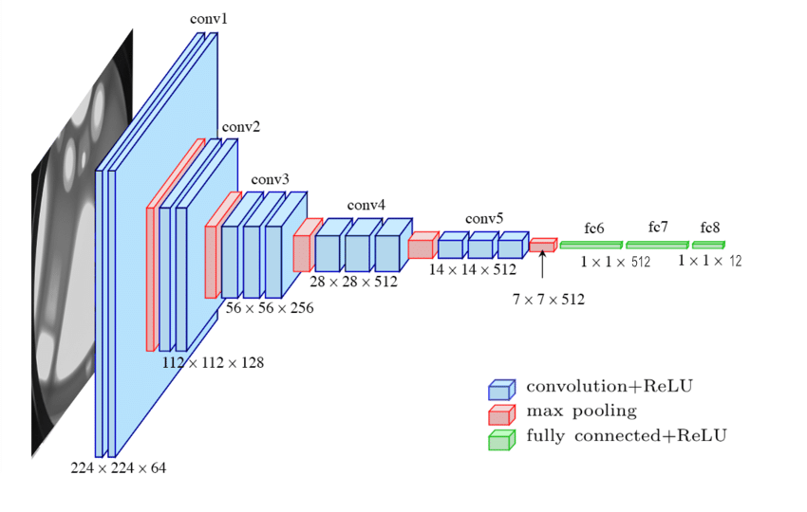

**A NOTE ON MACHINE LEARNING**

Machine learning is a method of data analysis that automates analytical model building. It is a branch of artificial intelligence based on the idea that systems can learn from data, identify patterns and make decisions with minimal human intervention. This project made extensive use of machine learning to achieve the objectives stated above.

**What is a CNN?**

Convolutional neural networks refer to a sub-category of neural networks: they, therefore, have all the characteristics of neural networks. However, CNN is specifically designed to process input images. Their architecture is then more specific: it is composed of two main blocks.

The first block makes the particularity of this type of neural network since it functions as a feature extractor. To do this, it performs template matching by applying convolution filtering operations. The first layer filters the image with several convolution kernels and returns “feature maps”, which are then normalized (with an activation function) and/or resized.

This process can be repeated several times: we filter the features maps obtained with new kernels, which gives us new features maps to normalize and resize, and we can filter again, and so on. Finally, the values of the last feature maps are concatenated into a vector. This vector defines the output of the first block and the input of the second.

The second block is not characteristic of a CNN: it is in fact at the end of all the neural networks used for classification. The input vector values are transformed (with several linear combinations and activation functions) to return a new vector to the output. This last vector contains as many elements as there are classes: Element i represents the probability that the image belongs to class i. Each element is therefore between 0 and 1, and the sum of all is worth 1. These probabilities are calculated by the last layer of this block (and therefore of the network), which uses a logistic function (binary classification) or a softmax function (multi-class classification) as an activation function.

**Features in Machine Learning**

A feature is an individual measurable property or characteristic of a phenomenon being observed. Choosing informative, discriminating and independent features is a crucial step for effective algorithms in pattern recognition, classification and regression. Feature extraction involves reducing the number of resources required to describe a large set of data. When performing analysis of complex data one of the major problems stems from the number of variables involved. Analysis with a large number of variables generally requires a large amount of memory and computation power; also it may cause a classification algorithm to overfit to training samples and generalize poorly to new samples.

CNN works by storing features of images into an n-dimensional vector called feature vector. This feature can be as simple as pixel values of the image to more complex ones like hough transform. For our project features that were important for us were color, shape, texture, contours of diseases in the leaf. A reason why CNN is exceptionally good at working with images is that the large number of parameters present in the neural network allows it to “see” even the tiniest of features in the image; without us explicitly telling it to.

**Layers of a CNN –**

1) The convolutional layer - The first layer in a CNN is always a Convolutional Layer. The convolutional layer is the key component of convolutional neural networks, Its purpose is to detect the presence of a set of features in the images received as input. The convolution layer’s parameters consist of a set of learnable filters. Every filter is small spatially (along width and height), but extends through the full depth of the input volume. For example, a typical filter on a first layer of a ConvNet might have size 5x5x3 (i.e. 5 pixels width and height, and 3 because images have depth 3, the color channels). During the forward pass, we slide (more precisely, convolve) each filter across the width and height of the input volume and compute dot products between the entries of the filter and the input at any position. As we slide the filter over the width and height of the input volume we will produce a 2-dimensional activation map that gives the responses of that filter at every spatial position. Intuitively, the network will learn filters that activate when they see some type of visual feature such as an edge of some orientation or a blotch of some color on the first layer, or eventually entire honeycomb or wheel-like patterns on higher layers of the network. Now, we will have an entire set of filters in each CONV layer (e.g. 12 filters), and each of them will produce a separate 2-dimensional activation map. We will stack these activation maps along the depth dimension and produce the output volume.

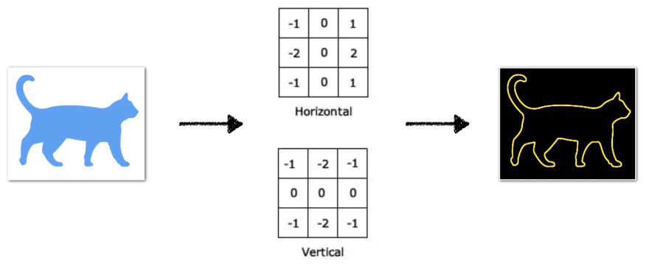

2) The pooling layer– It is common to periodically insert a Pooling layer in-between successive Conv layers in ConvNet architecture. Its function is to progressively reduce the spatial size of the representation to reduce the amount of parameters and computation in the network, and hence to also control overfitting. The Pooling Layer operates independently on every depth slice of the input and resizes it spatially, using the MAX operation. The most common form is a pooling layer with filters of size 2x2 applied with a stride of 2 down samples every depth slice in the input by 2 along both width and height, discarding 75% of the activations. Every MAX operation would in this case be taking a max over 4 numbers (little 2x2 region in some depth slice). The depth dimension remains unchanged.

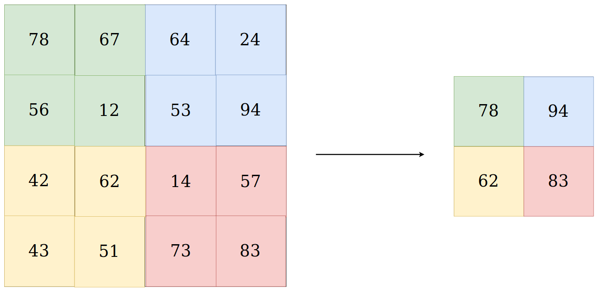

More generally, the pooling layer:

Accepts a volume of size W1×H1×D1W1×H1×D1

Requires two hyperparameters:

* their spatial extent F,
* the stride S,

Produces a volume of size W2×H2×D2 where:

* W2=(W1−F)/S+1
* H2= (H1−F)/S+1
* D2=D1

3) Fully connected layer - Fully Connected Layer is simply, feed forward neural networks. Fully Connected Layers form the last few layers in the network. The input to the fully connected layer is the output from the final Pooling or Convolutional Layer, which is flattened and then fed into the fully connected layer.

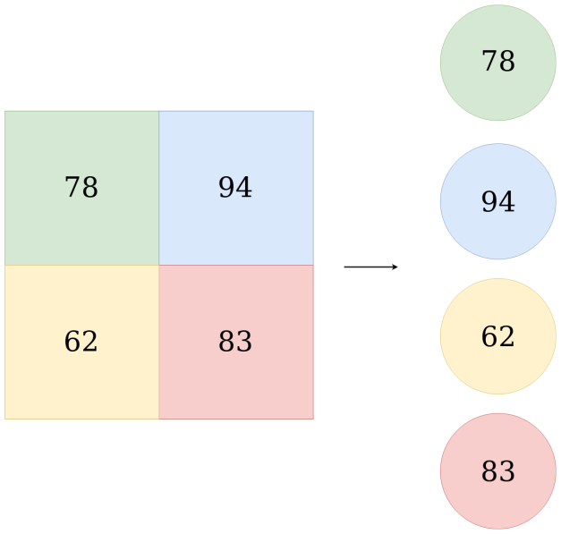

**Activation Function**

Activation functions are mathematical equations that determine the output of a neural network. The function is attached to each neuron in the network, and determines whether it should be activated (“fired”) or not, based on whether each neuron’s input is relevant for the model’s prediction. Activation functions also help normalize the output of each neuron to a range between 1 and 0 or between -1 and 1.

An additional aspect of activation functions is that they must be computationally efficient because they are calculated across thousands or even millions of neurons for each data sample. Modern neural networks use a technique called backpropagation to train the model, which places an increased computational strain on the activation function, and its derivative function.

**Role of the activation function in a neural network model**

In a neural network, numeric data points, called inputs, are fed into the neurons in the input layer. Each neuron has a weight, and multiplying the input number with the weight gives the output of the neuron, which is transferred to the next layer.

The activation function is a mathematical “gate” in between the input feeding the current neuron and its output going to the next layer. It can be as simple as a step function that turns the neuron output on and off, depending on a rule or threshold. Or it can be a transformation that maps the input signals into output signals that are needed for the neural network to function.

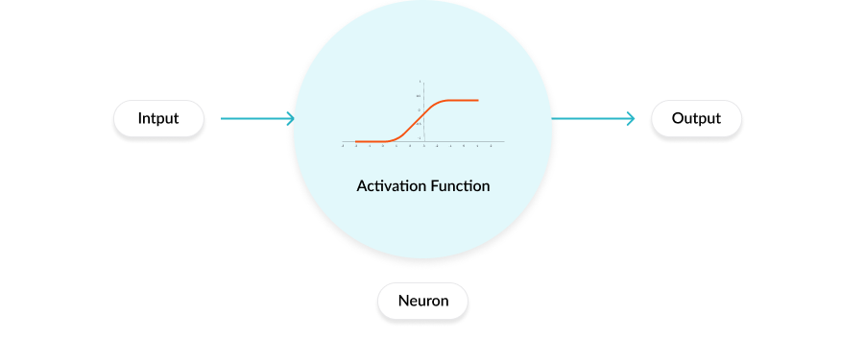

Increasingly, neural networks use non-linear activation functions, which can help the network learn complex data, compute and learn almost any function representing a question, and provide accurate predictions.

**Optimization Functions**

The goal of machine learning and deep learning is to reduce the difference between the predicted output and the actual output. This is also called as a Cost function(C) or Loss function. Optimizers update the weight parameters to minimize the loss function. Loss function acts as guides to the terrain telling optimizer if it is moving in the right direction to reach the bottom of the valley, the global minimum.

**Gradient Descent**

Gradient descent is an iterative machine learning optimization algorithm to reduce the cost function. This will help models to make accurate predictions.

Gradient indicates the direction of increase. As we want to find the minimum point in the valley we need to go in the opposite direction of the gradient. We update parameters in the negative gradient direction to minimize the loss.

**Learning Rate**

Learning rate controls how much we should adjust the weights with respect to the loss gradient. Learning rates are randomly initialized.

Lower the value of the learning rate, slower will be the convergence to global minima.

A higher value for learning rate will not allow the gradient descent to converge

Since our goal is to minimize the cost function to find the optimized value for weights, we run multiple iterations with different weights and calculate the cost to arrive at a minimum cost.

**TRANSFER LEARNING**

Transfer learning is a machine learning technique where a model trained on one task is re-purposed on a second related task. For example a model which was developed to classify images of vehicles can classify images of humans as well. This method is employed when we do not want to code a neural network from scratch. This technique is employed when the amount of data available to train a model is scarce. The pre trained neural networks available to us have already been trained on millions of images and can classify images with high accuracy. By re using them we are employing the pre trained weights to extract features from our own dataset. Once the features the extracted we need to train a few classification layers to classify them accordingly. Training a new model from scratch may take millions of images and several days of training to achieve accurate results. Transfer learning can achieve this level of accuracy in a few hours.

Upon testing several models that we designed from scratch we learned that plant diseases are somewhat hard to classify. Due to the color similarity between the background, color of leaf and color of the diseased parts the models performed poorly on testing data. Hence it was clear to us that we need to employ some form of transfer learning on our dataset. There are three approaches for transfer learning:

1. Select Source Model - A pre-trained source model is chosen from available models. Many research institutions release models on large and challenging datasets that may be included in the pool of candidate models from which to choose from.
2. Reuse Model - The model pre-trained model can then be used as the starting point for a model on the second task of interest. This may involve using all or parts of the model, depending on the modeling technique used.
3. Tune Model - Optionally, the model may need to be adapted or refined on the input-output pair data available for the task of interest.

Some of the available pre trained models are:

1. Xception
2. VGG16
3. ResNet50
4. InceptionV3
5. DenseNet

We tested all of the above models on our dataset and VGG16 yielded the most accurate result. Hence we reused this network architecture retaining all the previously trained weights but replacing the final classifying layers.

**IMPLEMENTATION OF NEURAL NETWORK**

The neural network we dseigned was constructed taking the well knowned VGG 16 architecture as the base. VGG 16 is a convolutional neural network architecture proposed by K. Simonyan and A. Zisserman from the University of Oxford in the paper “Very Deep Convolutional Networks for Large-Scale Image Recognition”. is trained on ImageNet dataset which has over 14 million images and 1000 classes, and achieves 92.7% top-5 accuracy. The name VGG-16 comes from the fact that it has 16 layers. Its layers consist of Convolutional layers, Max Pooling layers, Activation layers, Fully connected layers. Conv 1 has number of filters as 64 while Conv 2 has 128 filters, Conv 3 has 256 filters while Conv 4 and Conv 5 has 512 filters.

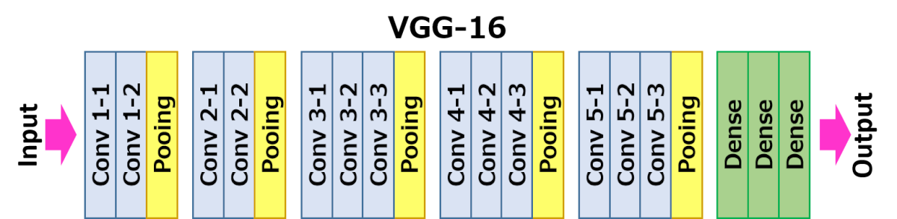

We retained all the layers of this architecture except the last Dense layers. The original model was trained to classify between 1000 classes of real world objects. But we had only 12 classes. So we changed the configuration of the last 3 layers to match our problem. The layers we added are as follows:

* One Dropout layer of 0.4 % dropout. This layer randomly deactivates 40% of the neurons. It is used to prevent overfitting.
* One Dense layer of 512 neurons with relu activation
* One final Dense layer of 12 neurons with softmax activation.

Since VGG 16 is a pre trained neural network we didn’t train its original layers again. Doing so would disrupt its weights and cause trouble in the feature extraction process. We freezed the weights of Convolution blocks 1 to 5. They were used to extract features from the input image. After the image passes through all the Convolution blocks we are left with a feature vector. The last two Dense layers flatten this feature vector into an array. The last layer uses softmax activation function which gives us a 12 valued array as output. Each value of this array corresponds to the respective class probability. At the end we ended up with a Neural Network with 135,312,460 total parameters. Out of these 1,051,916 parameters were trainable while 134,260,544 parameters were non – trainable. Parameters constitute the number of “learnable” elements that are present in a Neural Network. A large number of parameters allow the Network to learn more complex patterns in data. However this also increases the computational strain on the system.

**METHODOLOGY OF DETECTION SYSTEM**

**Data Collection**

The accuracy of a neural network largely depends on the quantity and quality of training data provided during the training phase.

Each Step of Data collection is given below-

Image Acquisition – We gathered about 1000 images of each disease for training and validation purpose. The images were downloaded from internet as well as taken manually from the fields of Assam Agricultural University. The authenticity of the disease in each image was verified by experts. Care was taken not to include inconsistent or unclear images that might cause the Neural Network to train improperly.

Image Segmentation – Image segmentation is the process of removing unwanted parts of the image. In our case the background of the images was removed as they did not have any significant contribution towards training. Moreover we were only interested in the diseased portion of a leaf so the corresponding healthy parts were removed as well. Further to increase the computational efficiency of our Model the dimension of the images were scaled down to 256 x 256.

Labeling – Once the images were processed they were put in folders which were named according to the class they belong to. The folders were separated as training and validation. The training folder contained 700 images of each disease while validation consists of 300 images of each class.

To find out whether the leaf is diseased or healthy, certain steps must be followed i.e., Preprocessing, Feature extraction, Training of classifier and Classification. Preprocessing of image is bringing all the images size to a reduced uniform size. Then comes extracting features of the processed image, which is done with the help of convolution layers. Extracted features can be as simple as edges, colors to more complex ones like entropy, energy etc. In our case more important features were the shape of leaf, the color and texture of the leaf.

The first few layers of the neural network are primarily focused on edge detection. At first it tries to determine the type of crop the leaf belongs to. As we move deeper more complex features are calculated.

The last layer is a fully connected layer to the end of the network. This layer basically takes an input volume and outputs an N dimensional vector where N is the number of classes that the program has to choose from. In our case N is 12 since we have 12 classes of crops for classification. Each number in this N dimensional vector represents the probability of a certain class. For example, if the resulting vector is [0 .75 .25], then this represents a 0% probability that the image belongs to class 1, 75% probability that the disease belongs to class 2 and 25% probability that the disease belongs to class 3

**Algorithmic Depiction**

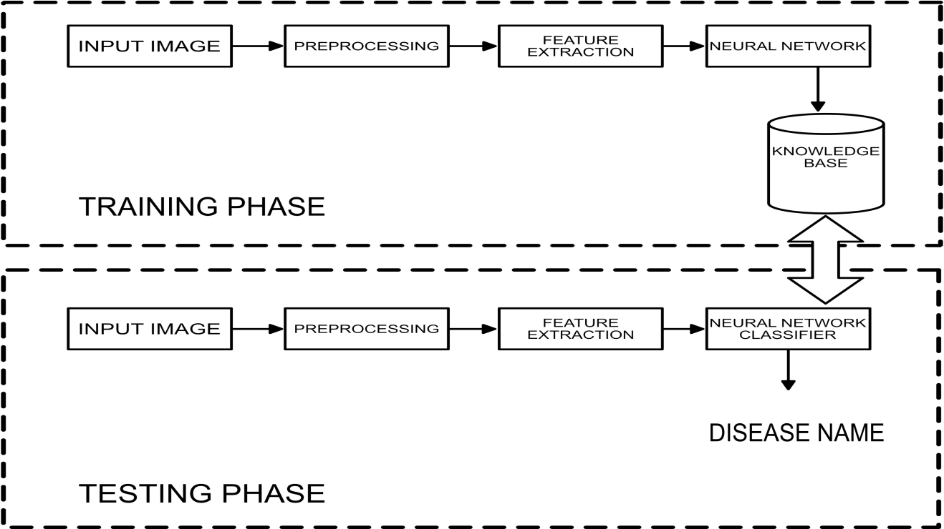

**Training of Neural Network –**

Training for the Neural Network was carried through Keras library in Python. Before feeding our data to the neural network we needed to make sure they are in the proper format. We used *ImageDataGenerator* method to resize our images into 224 by 224 pixels and separate them into batches of 20 images each. Separating them into batch is required because processing all the images at once will put huge strain on the processor and memory. After that we loaded the pre trained vgg16 model weights and add two fully connected layer each of 512 and 12 neurons respectively. The neurons needed to be connected into one single mesh for the algorithm to work. This step is called compiling the neural network and done through the *model.compile()* function. Compiling requires the optimizer type to use, the loss function and learning rate to train the model. Through extensive trial and error we found out that the *Adam* optimizer with a learning rate of *0.001* works best for our model. The loss function; since it is a multiclass classification needs to be *categorical_crossentropy*. After all the hyperparameters are set correctly we trained the model using *model.fit()* function for 400 epochs. Training took approximately 7 days to complete. Testing the neural network using real world data is very important to assess its performance. So we took a set of 10 images of each class that the neural network has never seen before. And then passed on these images for classification using the *model.predict()* function. The image went through the usual pre processing steps before classification. The model that performed best on testing data was saved as ‘best_model.h5’ using the *model.save()* function. Saving the model allowed us to load it again for drawing inference. The ‘h5’ format used for saving has the added benefit of saving the information required to training the model. Therefore the model can be loaded and trained again if required. The results of this testing are mentioned in the Results section

**IMPLEMENTATION OF FORUM**

Leafy forum is a sister module of the main Leafy project. It was designed as a platform for users to voice their doubts and queries.

Implementation of the sub modules are written below –

Registration: Users who wishes to use the forum will have to register first. After providing the necessary details and accepting the terms and conditions users will have their account created.

Login: This is the standard login module. Users will have to login first before calling any function that causes database modifications. The Login function simply verifies the given credentials against the existing user records.

Post Question: This function can only be called by logged in users. From the post question page users will have to select a suitable tag, title and write the body of the question. Images can be added to the question as well. All the fields here are mandatory.

Post Answer: Users can post answer to any question they like. Even answering user’s own question is allowed. Answer follows the same format as questions with a title and body. All the fields here are mandatory.

Edit Question: A registered user can edit his questions through this module.

Edit Answer: A registered user can edit his answers through this module.

Delete Question: A registered user is allowed to delete the questions posted only from his account. Upon confirmation the id of that particular question is sent for deletion and the question gets removed from the database. This will also delete any answers associated with that question

Delete Answer: A registered user is allowed to delete the answers posted only from his account. Upon confirmation the id of that particular answer is sent for deletion and the question gets removed from the database. Deleting answers has no affect on the question itself.

Edit profile: The user can change details in his profile anytime he wants. For changing of password a separate mail system is used to authenticate users.

Feedback: This module allows users to leave a feedback after using the system. Users will get an appreciation mail upon successful submission of feedback.

**Security Measures**

Regardless of how small or big it is every application needs some form of security measures against threats and vulnerabilities. Leafy was exposed to rigorous testing and debugging to find and plug loopholes. The website is protected against cross site forgery through *csrf_validation* token. Apart from that it is secured against SQL injection. The Uniform Resource Locators are protected with decorators such that only logged in users can access sensitive information.

**RESULTS OF DETECTION**

|  |  |  |  |  |  |
| --- | --- | --- | --- | --- | --- |
| Serial Number | Image Class | True Prediction | False Prediction | Total Images | Accuracy |
| 1 | Cherry Powderry mildew | 7 | 3 | 10 | 70% |
| 2 | Corn Common rust | 6 | 4 | 10 | 60% |
| 3 | Corn healthy | 6 | 4 | 10 | 60% |
| 4 | Corn Northern Leaf blight | 7 | 3 | 10 | 70% |
| 5 | Potato Early blight | 8 | 2 | 10 | 80% |
| 6 | Potato healthy | 8 | 2 | 10 | 80% |
| 7 | Potato Late blight | 6 | 4 | 10 | 60% |
| 8 | Squash Powdery mildew | 7 | 3 | 10 | 70% |
| 9 | Tomato healthy | 7 | 3 | 10 | 70% |
| 10 | Tomato Late blight | 7 | 3 | 10 | 70% |
| 11 | Tomato Yellow leaf curl virus | 8 | 2 | 10 | 80% |

**SYSTEM TESTING**

Every application needs to be thoroughly tested to eliminate runtime errors. This is a significant step in the software development cycle. Leafy was tested through two stages. The first one being white box testing and the second was second black box testing. The tests are described below:

**White Box Testing:**

This testing was carried out during the development phase exclusively by the developers. The modules were tested to see if they correctly perform the functionality meant for. Codes of each module were also checked to correct logical errors in the code. Optimizing the code was one of the chief goals of this phase. Duplicate codes were removed with clean non-repetitive functions.

**Black Box Testing:**

During this phase the application was distributed to a closed community of Users such as the guide for this project, friends and family members. All the participants here had little to no knowledge about the workings of the system. They were simply asked to provide inputs and record their observations. The main goal of this phase was to identify corner cases and invalid inputs.

Summary of the test carried out is given below:

|  |  |  |  |
| --- | --- | --- | --- |
| Functions | Test cases Executed | Test cases Passed | Percentage of pass |
| Login | 100 | 100 | 100% |
| Register | 100 | 98 | 98% |
| Prediction | 100 | 96 | 96% |
| Edit profile | 100 | 98 | 98% |
| Feedback | 100 | 100 | 100% |
| Post Question | 100 | 96 | 96% |
| Edit Question | 100 | 99 | 99% |
| Delete Question | 100 | 100 | 100% |
| Post Answer | 100 | 97 | 97% |
| Edit Answer | 100 | 99 | 99% |
| Delete Answer | 100 | 100 | 100% |

**SNAPSHOTS OF WEBSITE**

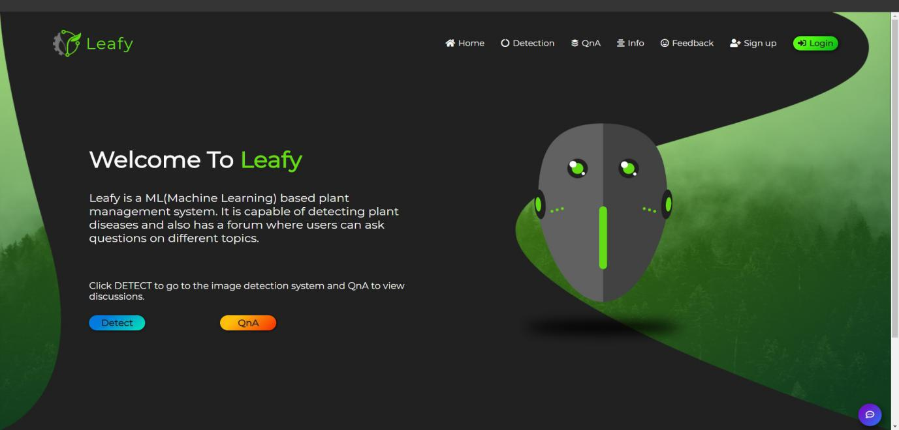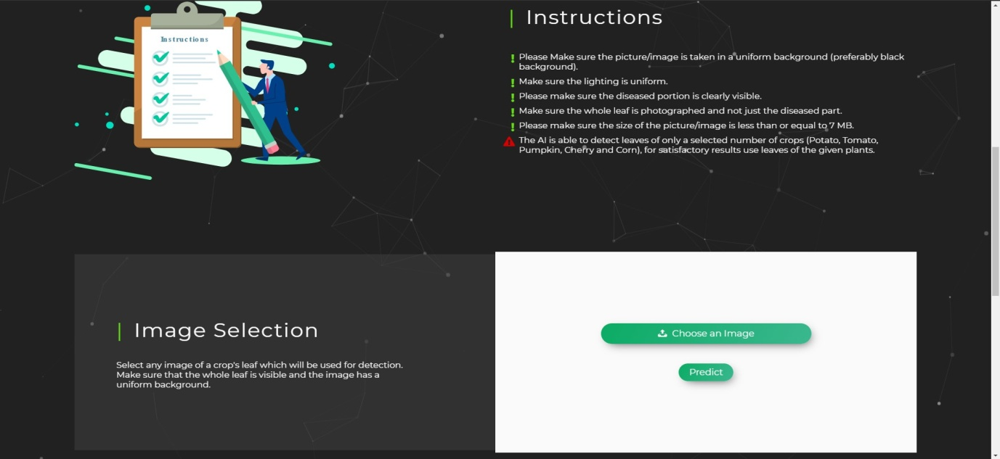

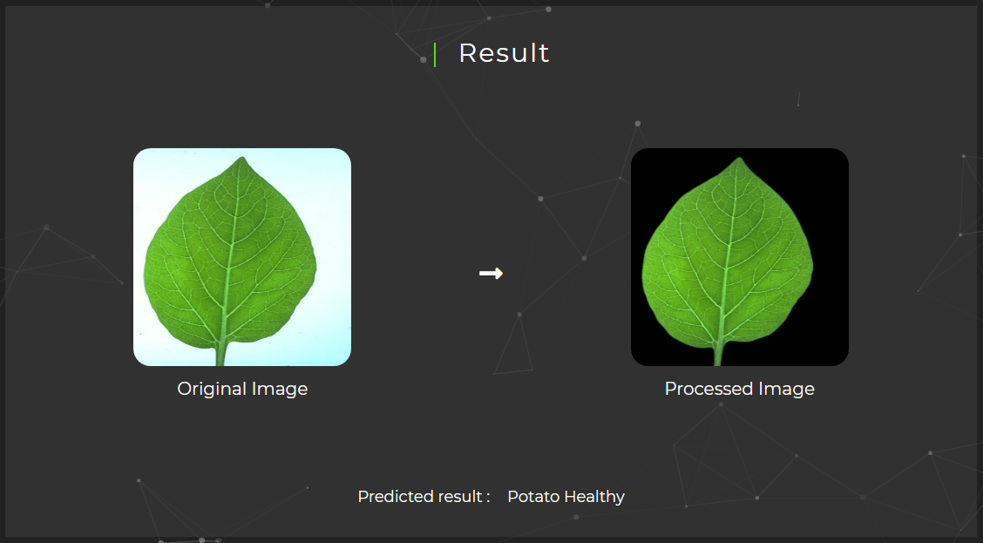

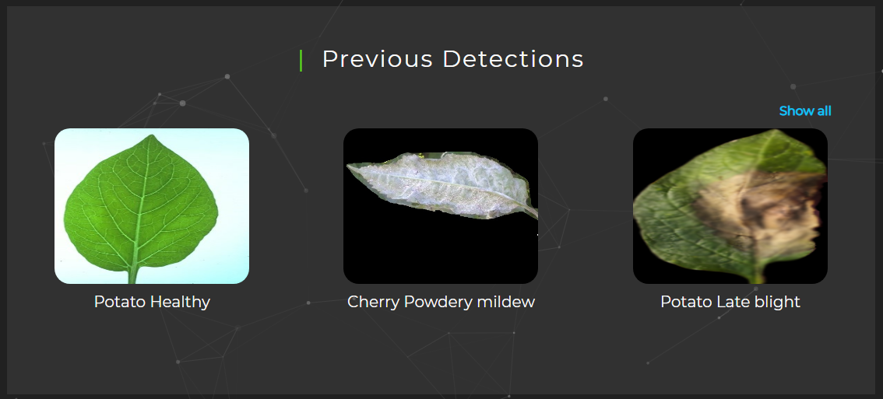

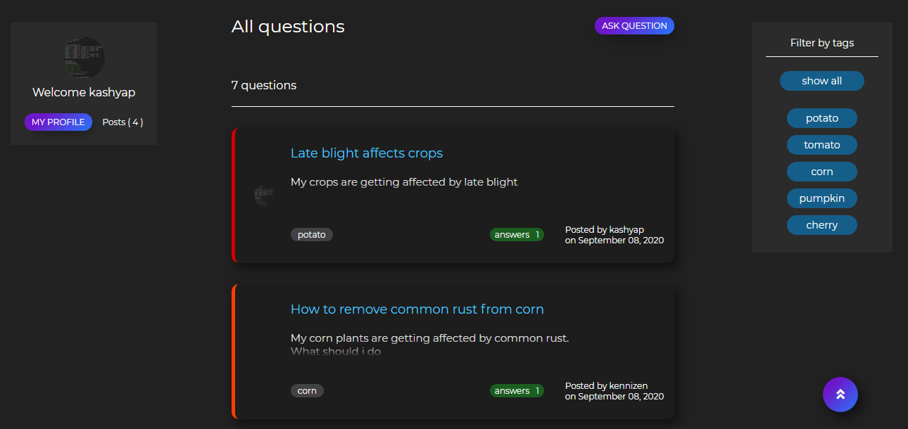

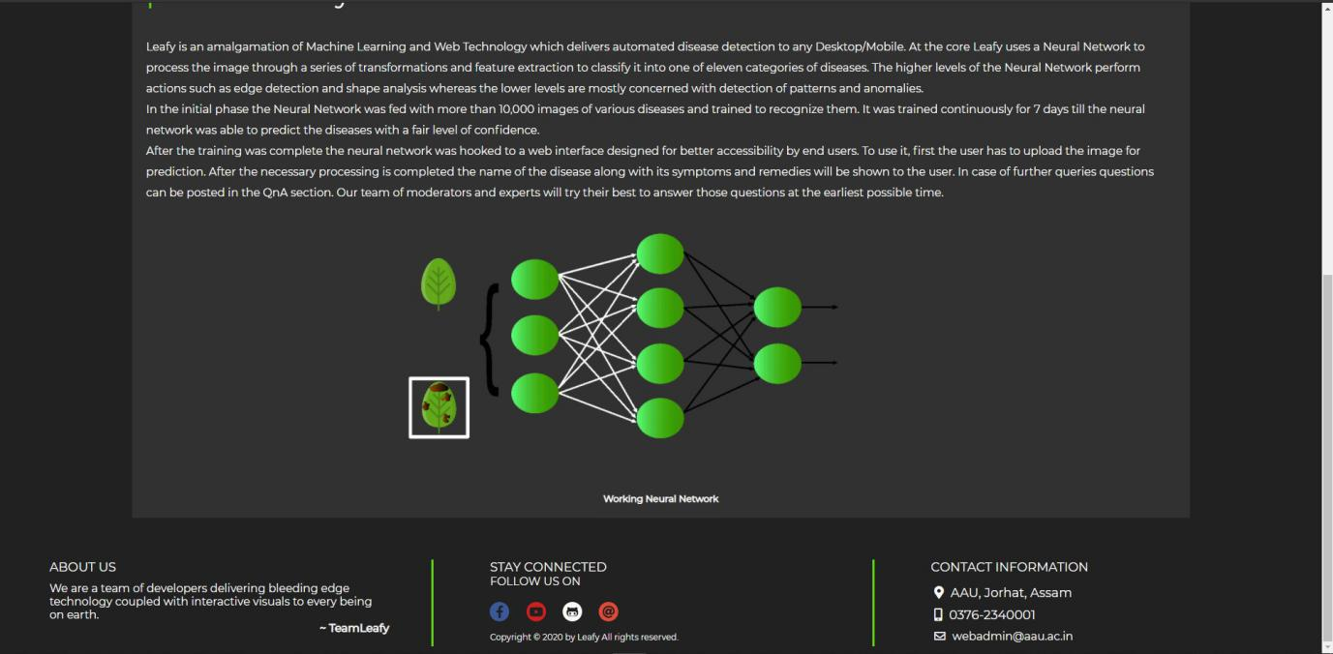

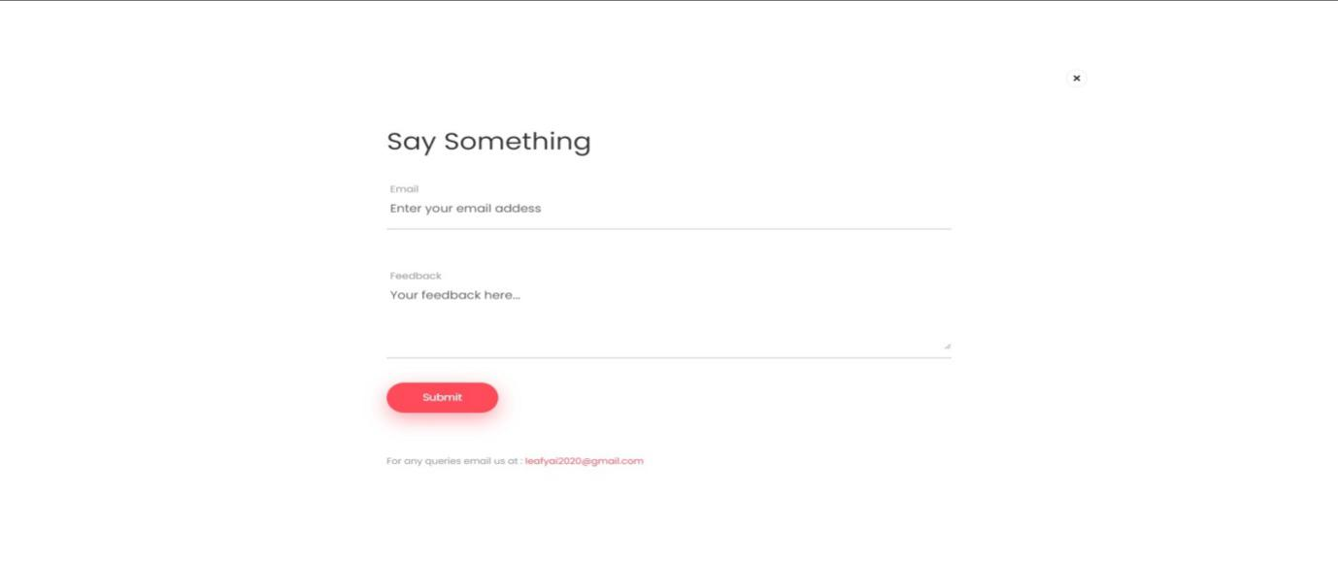



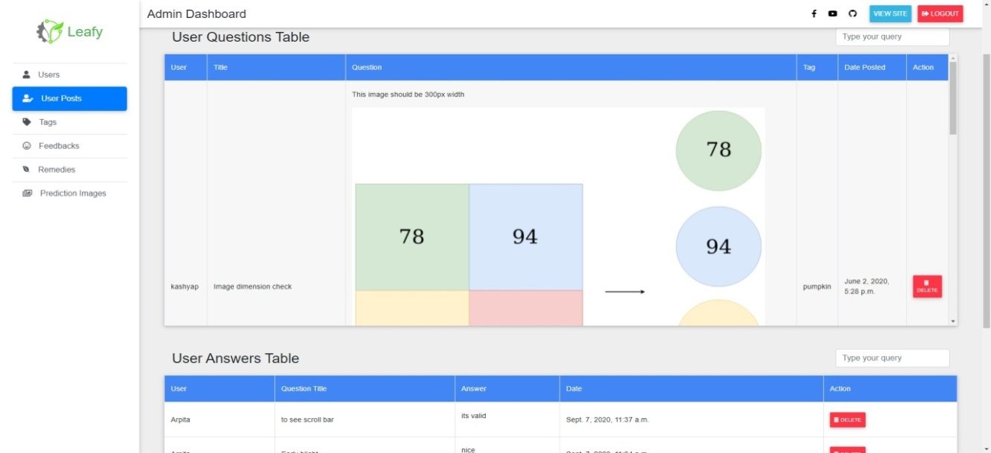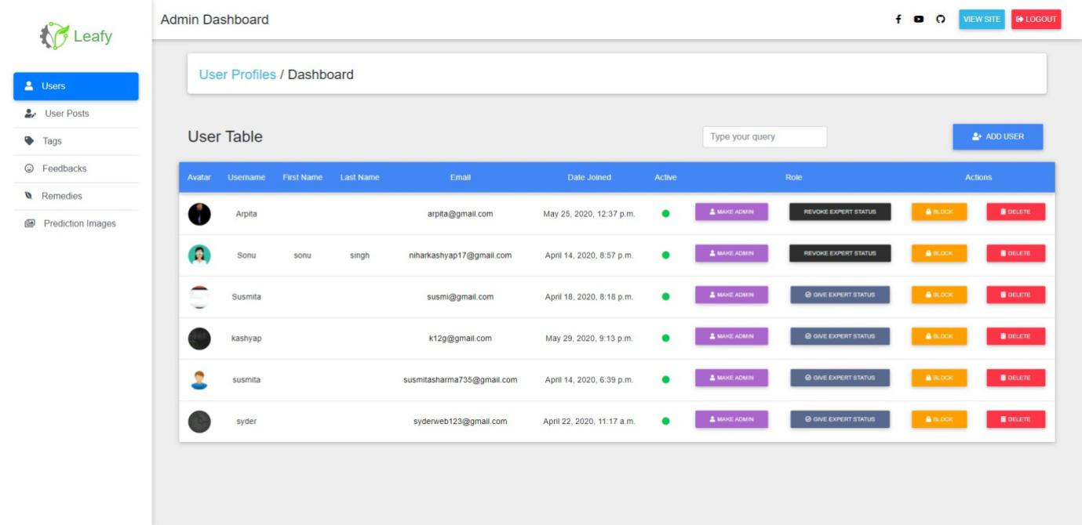

**CONCLUSION**

Agriculture has the potential to change the economic status of any country. Use of modern technologies will help us reap the maximum benefit from this sector. Leafy was a humble effort at bringing this technology to the hands of the common people. With the rapid advancement in technology as well as reduced costs it won’t be long before people are able to diagnose their agricultural problems on their own. Having said that our project is still some distance away from this scenario. It will take collaboration from all fields to build a foolproof and flawless application that can manage diseases of all kinds of plants. The proposed system can be made better through more research and optimization such that the accuracy of prediction increases as well as the bandwidth and memory requirements decrease. Furthermore the web application can be converted to an Android Application such that users can directly use their Smartphone cameras to click and upload photos to the server. Thus we can positively say Artificial Intelligence and Web technologies can together accomplish great things in the future.

**BIBLIOGRAPHY**

* D. Lee, Kent, 2014. Python Programming Fundamentals. Springer - Verlag London 2014. pp 115 -136
* Cleophas, Tony J and Zwinderman, Aeilko H., 2015. Machine Learning in Medicine- A Complete Overview. Springer International Publishing Switzerland 2015. pp 445- 469
* Burger, Wilhelm. Burge, Mar J., 2016. Digital Image Processing. Springer - Verlag London 2016, 2018. pp 37 – 406
* Skansi, Sandro, 2018. Introduction to Deep Learning. Springer International Publishing AG, part of Springer Nature 2018. pp 51 - 130
* Aggarwal, Charu C., 2018. Neural Networks and Deep Learning. Springer International Publishing AG, part of Springer Nature 2018. pp 17- 373
* Elmasri, Ramez and Navathe, Shamkant B., 2011. Fundamentals of Database Systems. Pearson Education 2011. pp 29 – 49
* Sun, Xiaolin and Wei, Jiangshu. 2019. Identification of maize disease based on transfer learning. IOP Publishing 2019.
* Ferentinos, Konstantinos P., 2018. Deep learning models for plant disease detection and diagnosis. Elsevier B.V. 2018.
* Saha, Anubhav, Krisabh, Dey, Sougata, Hema, D. Deva., 2019. Mulberry Leaf Disease Detection using Deep Learning. Blue Eyes Intelligence Engineering & Sciences publication 2019. pp 3368 - 3369

**WEB REFERENCES**

* <https://docs.djangoproject.com/en/3.0/>
* <https://medium.com/@randylaosat/a-beginners-guide-to-machine-learning-dfadc19f6caf>
* <https://www.youtube.com/watch?v=g-aS9oVY-DA>
* <https://medium.com/fintechexplained/how-to-fine-tune-your-machine-learning-models-to-improve-forecasting-accuracy-e18e67e58898>
* <https://towardsdatascience.com/everything-you-need-to-know-about-neural-networks-and-backpropagation-machine-learning-made-easy-e5285bc2be3a>
* <https://machinelearningmastery.com/convolutional-layers-for-deep-learning-neural-networks/>
* <https://towardsdatascience.com/how-to-deploy-a-machine-learning-model-dc51200fe8cf>
* <https://medium.com/machine-learning-through-visuals/performance-metrics-machine-learning-through-visuals-84ebd7cdcc20>
* <https://stackoverflow.com/questions/tagged/keras>
* <https://www.tensorflow.org/api_docs/python/tf/keras>
* <https://libguides.cu-portland.edu/Chicago_style/bibliography>